

**MDB 3053**

**ENGINEERING TEAM PROJECT**

GROUP 7 FINAL REPORT

Supervisor : Dr. Nor Erniza Binti Mohammad Rozali

Title : Aide Glasses

|  |  |  |
| --- | --- | --- |
| **NO.** | **NAME** | **MATRIC NO.** |
| 1 | Muhammad Fathy Rashad | 25547 |
| 2 | Bushra Binti Mohamad Zakir | 25297 |
| 3 | Fiorentina Richelle Asun | 25473 |
| 4 | Ahmad Kamal Bin Kamaluddin | 24843 |
| 5 | Megat Khairil Azlan Bin Adlin Azam | 24870 |
| 6 | Syed Amir Hilmy Bin Syed Halim | 25427 |

**ABSTRACT**

Hearing impairment limits one’s ability to undergo even the simplest routines in their daily life as they are unable to hear or experiencing hearing deficiency. However, in the advancement of today’s technology, hearing-impaired people are given chances to communicate with individuals around them only with the help of their own smartphones and a pair of modified glasses. The aim of this project is to design a smart glass capable of assisting direct communication between a hearing-impaired person and an able-bodied person in a way that is instinctual while also considering the cost. This glasses were designed to help people with hearing impairments to be able to perceive words uttered by the person talking to them through visual stimuli. It is called Aide Glass. It functions by capturing sound waves coming from the person they talk to with the help of microphone and transferring them to the cloud to be processed into text using speech recognition technology. The processed words will then be visually displayed onto a screen which can be seen through the glasses in the form of subtitles. Hence, using the technology stated, this glasses are able to help hearing-impaired people to communicate without actually hearing the words uttered to them, but ‘sees’ them. Smart glasses is economical as it costs only RM 178.48 to be built and its commercial price is only RM300 which is way cheaper if compared to hearing aids which cost at least RM3500. Thus, smart glasses can be a good future potential to those suffering with hearing impairments.

TABLE OF CONTENTS

|  |  |  |
| --- | --- | --- |
| **No.** | **Content** | **Page Number** |
| **1.** | **Introduction** |  |
| 1.1 | Background of Project | 4 – 5 |
| 1.2 | Problem Statement | 6 |
| 1.3 | Objective | 7 |
| 1.4 | Literature Review | 8 - 9 |
| **2.** | **Procedure and Analysis** |  |
| 2.1 | Application of Design Thinking | 10 - 13 |
| 2.2 | Approach to Solutions / Methodology | 14 - 22 |
| 2.3 | Fundamental Engineering Analysis | 23 - 31 |
| **3.** | **Results** |  |
| 3.1 | Technical Specifications and Engineering Drawing | 32 – 38 |
| 3.2 | Project Output | 39 - 40 |
| 3.3 | Discussion on Result | 41 - 42 |
| 3.4 | Cost analysis | 43 – 46 |
| 3.4 | Conclusion | 47 |
| 3.5 | Recommendations | 48 - 49 |
| **4.** | **Project Management** |  |
| 4.1. | Gantt Chart | 50 - 51 |
| 4.2. | Task Allocation | 52 - 55 |
| **5** | **Appendices** |  |
| 5.1. | References | 56 - 58 |

**1. INTRODUCTION**

This section discusses the background of project, problem statement, objective and literature review.

**1.1 BACKGROUND OF PROJECT**

Hearing loss and deafness are very common worldwide. A study from World Health Organization (2019) stated that over 5% of the total world’s population, which is around 466 million people, are suffering with disabling hearing loss. The value is estimated to increase in 2050 by 434 million more, added up to 900 million people in total who will have disabling hearing loss in the future.

As categorized by Felman (2018), there are three different level of hearing loss which are hearing loss, deafness and profound deafness. He stated that hearing loss are said to be occurred when someone’s ability to hear has deteriorated compared to other normal people, meanwhile deafness is inability of a hearing impaired person to understand speech even when the sound has been amplified and lastly, profound deafness is a total loss of hearing ability, making a person with it unable to perceive sound at all.

There are many causes for someone to acquire hearing loss, but the major ones are due to aging and excessive exposure to loud noise be it for short or long period of time (Mayo Clinic, 2019). Aging is uncontrollable and some aged people experience hearing loss as their inner ear degenerates over time (Mayo Clinic, 2019). As aging happens naturally, exposure to loud noise do not. It can be controlled by taking appropriate measures such as wearing hearing protection, turn down the volume if possible, walk away from the area, avoid places with loud noise, and taking breaks (Centers for Disease Control and Prevention, n.d.).

Despite the frightening amount of people with hearing loss, there are ways discovered to assist people with this impairment. As stated by Felman (2018), hearing aids and cochlear implants are technologies invented to aid people with hearing loss and there are also other alternatives such as sign language and lip reading. While hearing aids and cochlear implants can help those with hearing loss, they cannot help people with deafness or profound deafness (World Health Organization, 2019). Those with profound deafness relies only on sign language and lip reading to assist them with their daily life.

In consideration to the above problem, it is of significance to invent Aide Glasses as an alternative for people with profound deafness to communicate. They can see the words spoken to them through this glasses in the form of subtitles which enables them to understand the person they are talking to without actually hearing them. Furthermore, these glasses is expected to cost only RM170 which is at least 20 times cheaper than the other available hearing aids in the market. According to Hear.com (n.d.), the costs for hearing aid in Malaysia range from RM3,500 for basic to RM14,000 for premium device. Meanwhile the price for cochlear implants range from RM70,000 to RM100,000 (The Star Online, 2015).

**1.2. PROBLEM STATEMENT**

There are several technologies that have been invented to help people with hearing impairments such as hearing aids and cochlear implants. However, these technologies are very expensive. Thus, many people could not afford them.

In addition, hearing aids and cochlear implants cannot help people with profound deafness as those with profound deafness are unable to perceive sound at all. Hearing aids and cochlear implants functions by amplifying sound but do not give the ability to hear (World Health Organization, 2019). Thus, it cannot help people who cannot hear at all. Therefore, they have to rely only on sign language and lip reading to communicate with others.

In response to these problems, a pair of smart glasses is designed specifically to help people with profound deafness. This glasses is economical as it is cheap and also practical as it is lightweight. Not only this glasses can help people with profound deafness, it can help those with hearing loss as well. Thus, this glasses can be a good alternative to replace the existing technologies.

**1.3. OBJECTIVE**

* To design smart glasses which works by capturing sound waves and processing them into texts.
* To explore the capabilities of voice recognition and smart glasses in helping hearing-impaired people.
* To produce a working prototype of smart glasses.
* To provide an inexpensive alternative to hearing aids.

**1.4. LITERATURE REVIEW**

The main motivation behind this project was to introduce a technology that would help the hearing impaired communicate better with hearing people. The World Health Organization estimates that 466 million people in the world suffer from some form of hearing impairment. With an aging population this number will only get higher. A new form of communication technology needs to be developed to meet this increasing demand. This will assist them in all aspects of life and perhaps increase their quality of life through the opening of new opportunities. The conventional technologies for hearing loss are prohibitively expensive, such as hearing aids. An in-depth study estimates the societal costs of severe to profound hearing loss in the US to be $297,000 per person during that person's life (Mohr, et al., 2000). This creates a burden on the hearing impaired where the less fortunate are left out of aid due to economic reasons. This leads to a decrease in their employment opportunities as there are not able to find employment due to their disability. The unemployment rate for those with hearing loss is 35 % which is significantly higher than able bodied people (Hill and Wicks, 2017). This creates a divide in the deaf community through social class; the wealthy and the non-wealthy. Problems also arise at the school level, where hearing students’ negative attitudes towards deaf students were based on their problems communicating with them, such as frustration, fear, unfamiliarity, misunderstanding, and averseness to outgroups in general (Stinson and Liu, 1999). This project hopes to equalize the deaf community with a revolutionary technology that is affordable to all.

Conventional hearing aids are not a miracle cure. Hearing aids only amplify the sounds it receives (Moore, 2004). They become troublesome when there are loud background noises or multiple people are speaking as it amplifies all sounds the same way. The best hearing aids on the market today can filter out sounds based on Digital Noise Reduction technology (DNR) such as the Siemens ACURIS Model S (Mueller, Weber, & Hornsby 2006) or employ the use of artificial intelligence to selectively receive or block sound. Another limitation of the hearing aids is that it relies upon the users natural hearing. People with mild hearing loss and intact auditory vestibular nerve will benefit immensely from hearing aids. Those who have damaged auditory vestibula nerve and thus are profoundly deaf will have no use for hearing aids. Hearing aids may only benefit a small portion of the deaf community due to its exclusivity and cost.

This project will utilize speech-to-text technology to translate auditory speech to visual characters. This will bypass the need for hearing aids in common communications. Speech recognition software has seen enormous growth in recent years. Every computer running windows has speech-to-text capabilities. All android phones use google speech to text software while Apple’s iPhone uses Apple Dictation. In recent years, the device called a home assistant was introduced to the public. This voice activated machine was created to assist users with their daily tasks such as recording shopping lists, play music, give reminders or search the internet, all with the user’s voice. The most popular of these devices are the Google Home, Amazon Alexa and the Apple Homekit. All interactions with the home assistant increase its vocabulary and incrementally improves the technology. The only aspect that these devices differ in each other is the appearance, in terms of functionality these home assistants are very similar with the same features. The limitations of these devices is that it only understands fixed scripted commands and a slight deviation from this may not execute the command at all or lead to misunderstandings. The top speech-to-text software has an accuracy rate of 94% (Huang, 2017). This technology lays the foundation for our project.

**2. PROCEDURE AND ANALYSIS**

The procedure, methodology and engineering analysis of the project will be covered in the following section.

**2.1. APPLICATION OF DESIGN THINKING**

A preliminary survey has been conducted to research the pain points of the problem.

The survey was carried out towards the general public to gather information on the potential interest in our product and to gauge public opinion on the issues faced by deaf people. The results from the survey are summarised in Fig 2.1.1 to Fig 2.1.7.

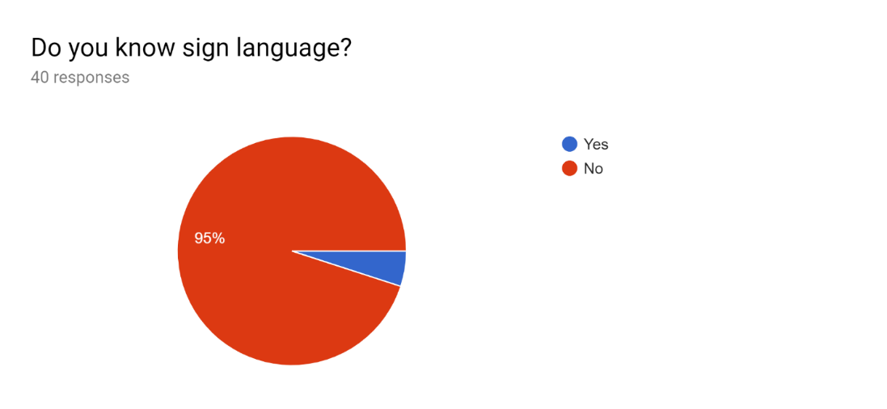

**Figure 2.1.1**

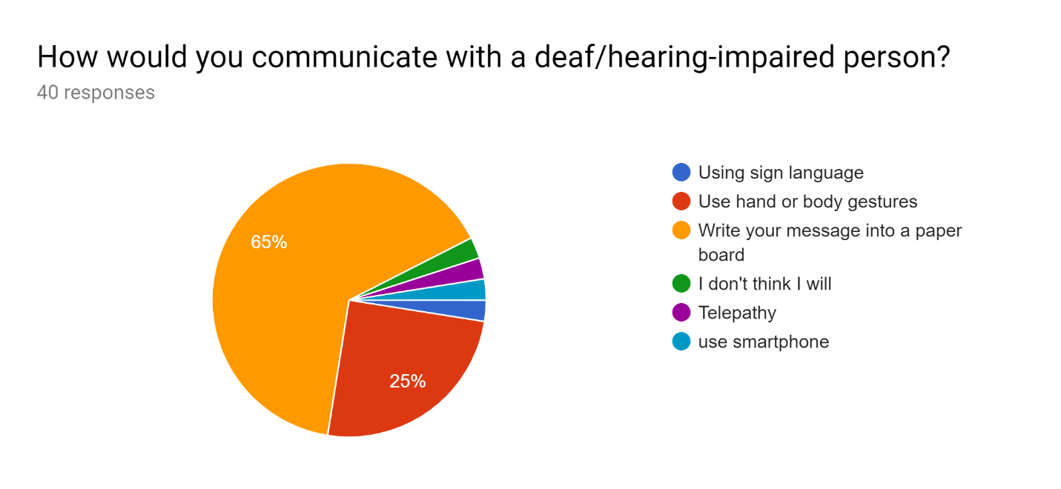

**Figure 2.1.2**

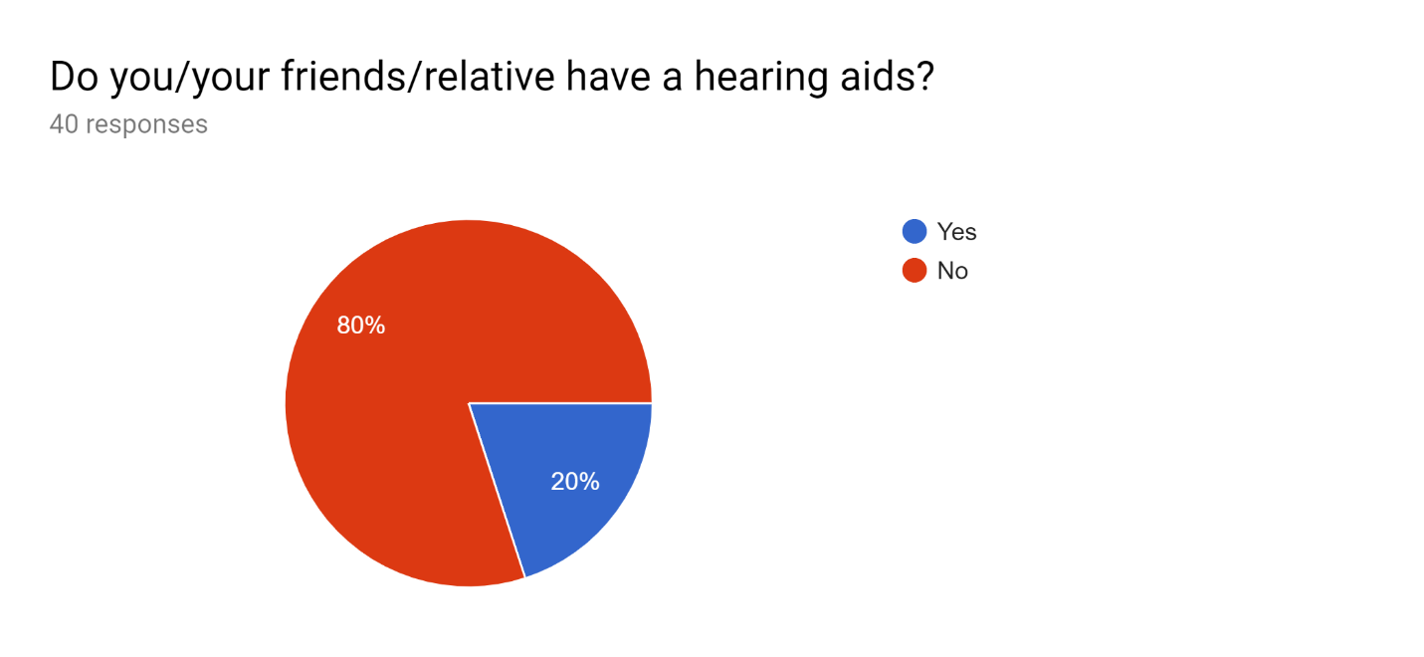

**Figure 2.1.3**

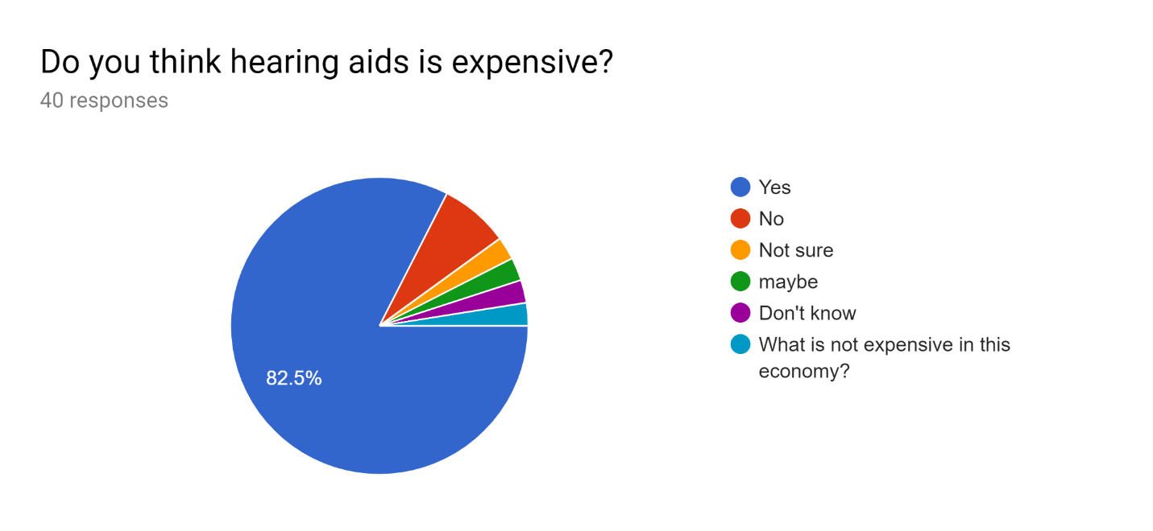

**Figure 2.1.4**

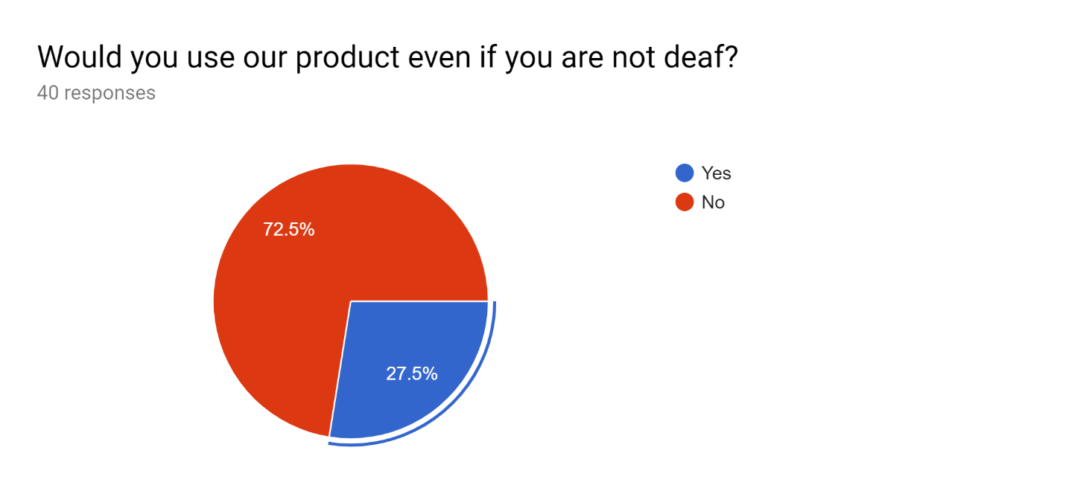

**Figure 2.1.5**

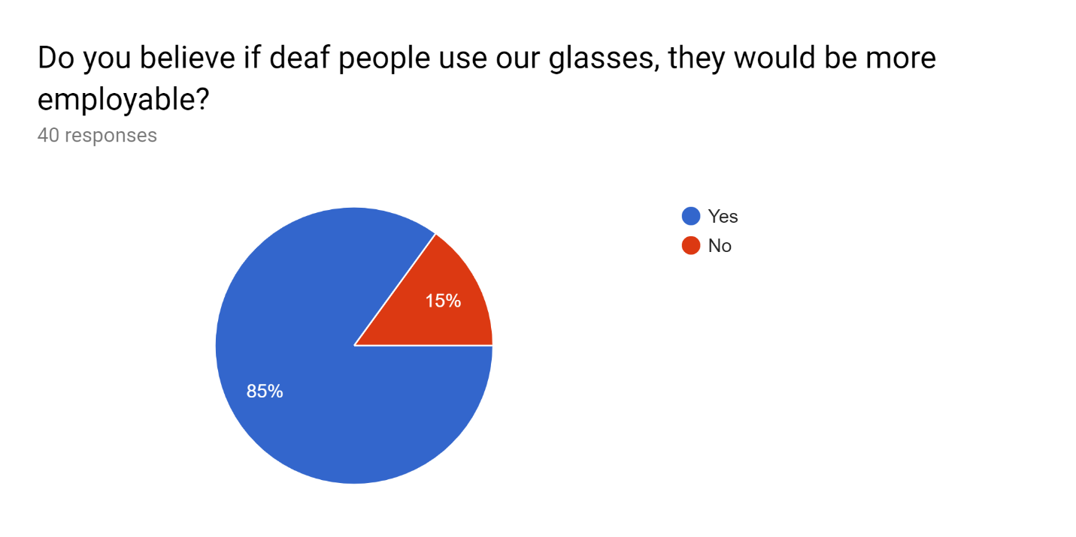

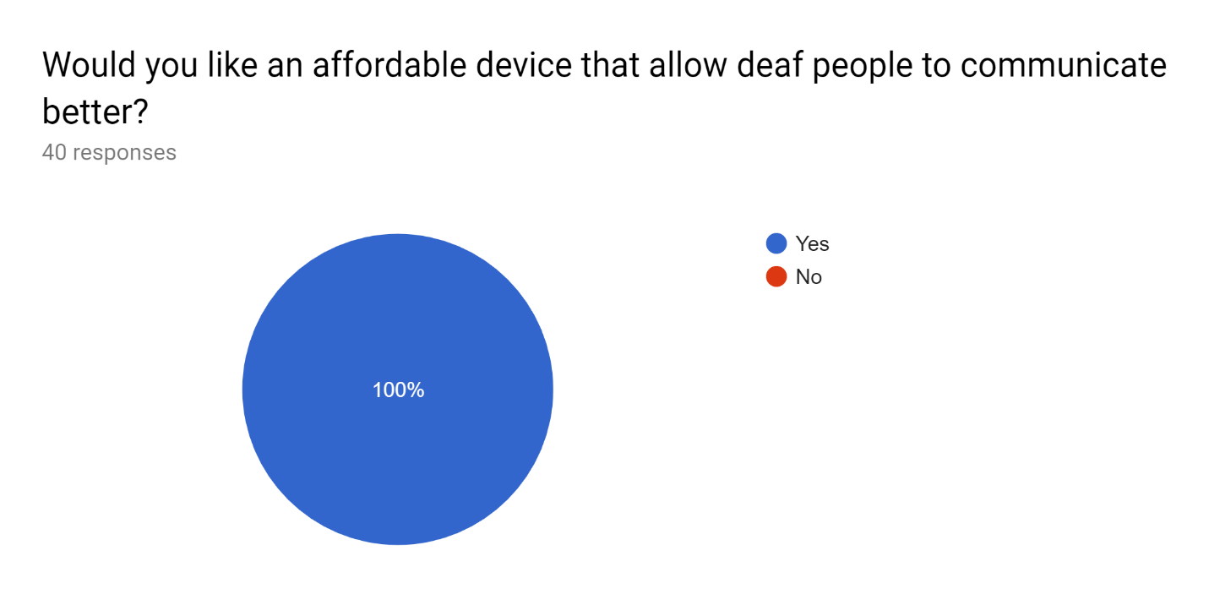

**Figure 2.1.6**

**Figure 2.1.7**

From the results of the survey, we found out that 95 % of respondents do not know sign language. When asked about the method of communication with deaf people, almost two thirds of respondents said that they would write on a paper to express what they want to say. Another quarter of respondents said that they would communicate using gestures of the hands and body. From figure 2.1.4, a surprising 20 % of respondents have a family member or relative who uses hearing aids and yet in figure 2.1.5, 82.5 % believe that hearing aids are too expensive. We believe that our product can improve the employability of deaf people and figure 2.1.7 shows that 85 percent of people agree with us. More than a quarter of people would use our product even though they are not deaf, in reference to figure 2.1.6. They specified that they would use it for language translation, information processing and to increase the range of their hearing. 100 % of respondents agree in affordable communication technology being made accessible to deaf people. Based on the data gathered from this survey, it shows that there is a demand and interest to further this project.

**2.2. APPROACH TO SOLUTIONS / METHODOLOGY**

**WORKFLOW OF PROJECT**

Figure 2.2.1 shows the overall workflow of the project from researching to completion of working prototype. The workflow includes components and methodology research, preparation and collection of materials, development and testing of software system proof of concept, construction of circuit design and testing of electrical prototype, fabrication of prototype casing or frame, assembly of prototype, and finally full testing and improvement of working prototype.

*Figure 2.2.1 Flowchart of the Workflow for the Project*

Aide Glasses is affordable smart glasses that helps hearing impaired people communicate better by showing them what other people are saying in the form of subtitles. The prototype mechanism consists of three stages as shown in Figure 2.2.2. A microphone was embedded inside the smart glasses which will be used to capture the voices of the surrounding people. Next, as the glasses are provided with Wi-Fi capability, the captured voices will be transmitted in real-time through the internet to Google Cloud services to be processed and transcribed by Google Speech-to-Text state of the art speech recognition technology. The resulting output of the transcribed text will be sent back to the glasses to be displayed to the users in the form of subtitles on the glass lens. The system overall flow of the prototype is shown in Figure 2.2.3 in the form of block diagram.

*Figure 2.2.2 General Process of the Working Mechanism*

*3*

**PROTOTYPE DESIGN**

The prototype design consists of components enclosed in a block of 3D printed casing that will be attached at the side of the glasses as shown in Figure 2.2.5. A reflector which is a transparent lens will be positioned at the front of the glasses as shown in figure 2.2.4 where the transcription output will be displayed to be seen by the user using the reflection of the display.

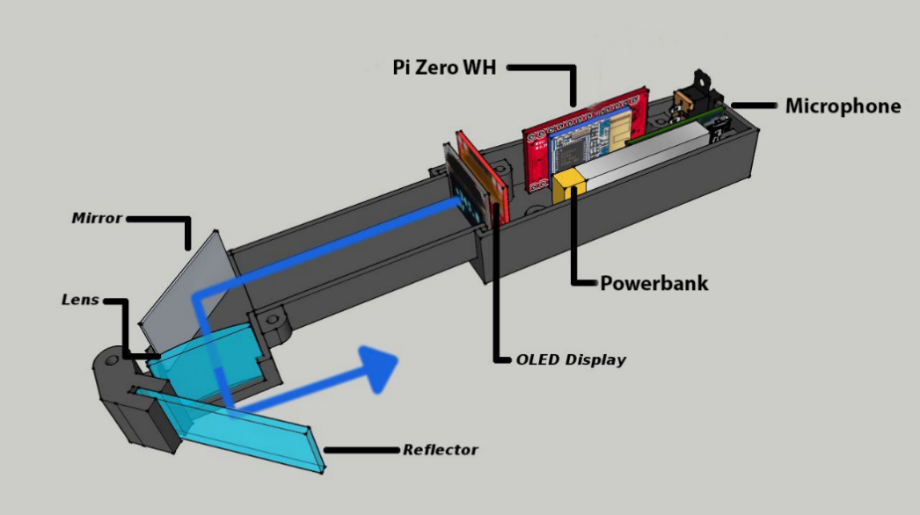

*Figure 2.2.4 internal view of the prototype*

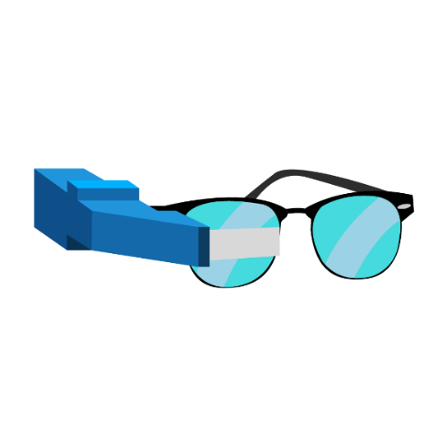

*Figure 2.2.5 external design of the Aide Glass*

**CIRCUIT DESIGN**

The circuit design of the prototype consists of four components, as shown in Figure 2.2.6. These four components are Raspberry Pi Zero WH (Wireless with Header), OLED (Organic Light Emitting Diode) display, mini power bank, USB (Universal Serial Bus) microphone, and micro USB to OTG (On-The-Go) adapter. Raspberry Pi WH is used as the microcontroller for the prototype where the program system will be run. The USB microphone is required to be able to record the conversation speech of the surrounding people digitally. The OTG adapter is needed to connect the USB microphone to the Raspberry Pi Zero WH, as it only has a micro USB slot instead of a USB slot. The OLED display will be used to display the transcribed text output which will be reflected to the lens. Finally, the power bank acts as the power management system which handles both power source and storage of the prototype.

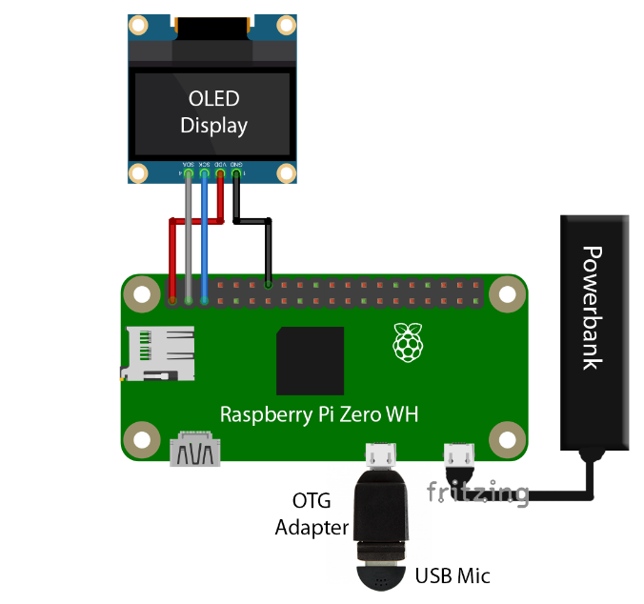

*Figure 2.2.6 circuit design for the prototype of the Aide Glass*

**SOFTWARE SYSTEM**

The software program of the prototype is critical to ensure the prototype gives the desired behavior. As shown in Figure 2.2.6, the program is run by the microcontroller when the microcontroller is turned on, and the program will start listening until an audio input is detected by the attached USB microphone. If an audio input is detected, it will check whether the audio input is a human voice or other disturbance noises. If the input is noise, it will keep listening again for human voice input, else the program will proceed in transmitting the audio input in real time to the Google Cloud Speech-to-Text service. Then the audio will be processed into transcribed text by Google speech recognition system in their powerful server. Then, the output of the processed audio which includes the transcribed text will be sent back to the prototype system. Finally, the received output of the transcribed text will be displayed on the OLED display component which will be reflected to the prototype lens and then the program will wait for the next input and repeat the same cycle.

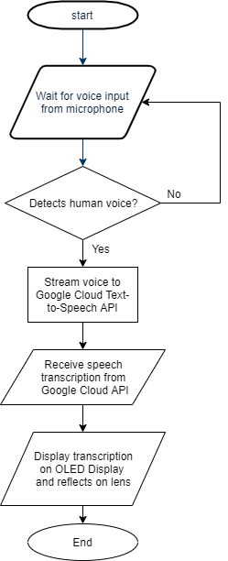

*Figure 2.2.7 Flowchart of the Software Program*

**SPEECH RECOGNITION SYSTEM**

The program uses Google Cloud Speech-to-Text service to do speech recognition of the audio input to the prototype. The features and capabilities of Google Cloud Speech-to-Text service is shown in Table 2.2.1, as extracted from the Google Cloud official documentation (Cloud Speech-to-Text, 2019).

*Table 2.2.1 Features of Google Cloud Speech-to-Text (Cloud Speech-to-Text, 2019)*

|  |  |
| --- | --- |
| **Feature** | **Description** |
| Powered by machine learning | The most advanced deep-learning neural network algorithms can be applied to audio for speech recognition with unparalleled accuracy. Cloud Speech-to-Text accuracy improves over time as Google improves the internal speech recognition technology used by Google products. |
| Recognizes 120 languages and variants | Cloud Speech-to-Text can support a global user base, recognizing 120 languages and variants. It can also filter inappropriate content in text results for all languages. |
| Automatically identifies spoken language | Using Cloud Speech-to-Text, it can identify what language is spoken in the utterance (limit to four languages). |
| Returns text transcription in real time for short-form or long-form audio | Cloud Speech-to-Text can stream text results, immediately returning text as it’s recognized from streaming audio or as the user is speaking. Alternatively, Cloud Speech-to-Text can return recognized text from audio stored in a file. It is capable of analyzing short-form and long-form audio. |
| Automatically transcribes proper nouns and context-specific formatting | Cloud Speech-to-Text is tailored to work well with real-life speech and can accurately transcribe proper nouns and appropriately format language (such as dates, phones numbers). |

**2.3 FUNDAMENTAL ENGINEERING ANALYSIS**

Proper research and analysis on the components have been done prior to designing the working mechanism. Comparison between alternative microcontrollers, fabrication materials and speech recognition systems have been made prior to selecting the final components.

**ALTERNATIVE DESIGN CONCEPTS**

We have explored and analyzed various suitable components, and comparisons have been made to decide on our final designs. Alternatives for microcontroller, display, and fabrication material have been analyzed and compared in the following section.

**MICROCONTROLLER COMPONENT**

A microcontroller is needed to run the program that would control the microphone and display to do the desired behavior. Two microcontrollers which are ESP32 LyraT and Raspberry Pi Zero WH have been analyzed and researched.

According to Espressif official documentation (ESP32-LyraT V4.3 Getting Started Guide, 2019), ESP32-LyraT is an open-source development board. It is designed for smart speakers and smart-home applications. It comes with a great variety of voice commands, interactive voice functions and a rich peripheral. It facilitates the quick and easy development of dual-mode (Bluetooth + Wi-Fi) audio solutions as shown in Figure 2.3.1a. It also has support for one-key Wi-Fi configuration, a wake-up button, voice recognition, cloud platform access, and a battery system. However, with many features embedded in the microcontroller, it comes with expensive price and bigger dimensions overall. The pros and cons of ESP32 LyraT have been analyzed and shown in Table 2.3.1.

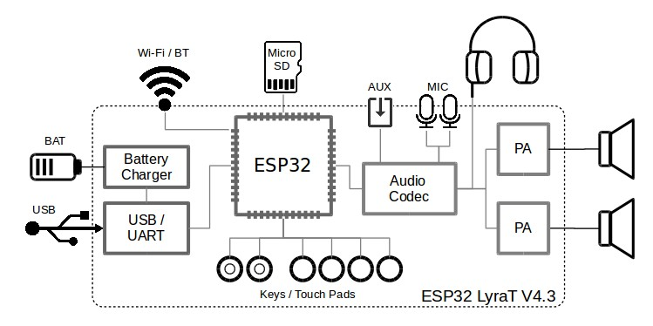

*Figure 2.3.1a schematic diagram of the ESP32 lyraT*

*Table 2.3.1 pros and cons of ESP32 LyraT (*ESP32-LyraT V4.3 Getting Started Guide, 2019)

|  |  |
| --- | --- |
| Pros | Cons |
| - Built-in Microphone  - Built in WiFi and Bluetooth  - Built in Voice Wake-up and Recognition -support  - Built-in battery power system | - Big size (95.5mm * 80.6mm)  - Expensive (RM108) (AliExpress, 2019)  - Lack of learning resources and tutorial  - Limited to use their SDK (Software Development Kit) |

Based on Raspberry Pi official website (Raspberry Pi Zero W, 2019), the Raspberry Pi Zero W extends the Pi Zero family and comes with added wireless LAN and Bluetooth connectivity. Raspberry Pi is a mini computer and has almost the same capabilities with other normal computers, hence offers more flexibility in terms of the software system. However, as Raspberry Pi do not come with audio input and power storage support, and an additional USB microphone and a powerbank are required for the prototype. The pros and cons of Raspberry Pi Zero WH has been analyzed and shown in Table 2.3.2.

|  |  |
| --- | --- |
| **Pros** | **Cons** |
| - Built in Wi-Fi and Bluetooth  - Small size (65mm x 30mm x 5mm)  - Cheap (RM75) (Shopee, 2019)  - Abundance of learning resources and tutorial.  - Flexibility of software capability. | - Need external microphone  - No built-in battery system |

*Table 2.3.2 Pros and cons of Raspberry Pi Zero WH*

Based on the two microcontrollers considered, the microcontroller that our group opted to implement is the Raspberry Pi Zero WH. The main reason for this choice is because Raspberry pi acts similarly as computer, therefore the software system that is tested on a computer before would work in Raspberry Pi. On the other hand, if ESP32 LyraT is used, there are risks of failure for the software systems either due to unsupported library or other unforeseen reasons. In addition, Raspberry Pi Zero WH is cheaper, smaller, flexible in term of software capabilities, and have more learning resources compared to the ESP32 LyraT. The comparison between the two is shown in Table 2.3.3.

*Table 2.3.3 Comparison between ESP32 LyraT and RPi Zero WH*

|  |  |  |  |  |
| --- | --- | --- | --- | --- |
| **Feature** | **RPi Zero WH** | **ESP32 LyraT** | **Suitability** | |
| **RPi Zero WH** | **ESP32 LyraT** |
| Size | 65mm*30mm*5mm | 95.5mm*80.6mm | Yes | No |
| Price | RM75 (Shopee,2019) | RM108 (AliExpress,2019) | Yes | No |
| Wifi & Bluetooth | Built-in | Built-in | Yes | Yes |
| Learning Resources | Common | Less common | Yes | No |
| Battery System | External | Built-in | No | Yes |
| Software Capability | Flexible | Limited | Yes | No |
| Microphone Support | External | Built-in | No | Yes |

**FABRICATION MATERIAL**

Various fabrication materials and methods have been explored and researched. 3D printed plastic material and cardboard have been considered to be applied in our project.

3D printing essentially is the process of using 3D digital models to create three-dimensional solid objects. The process of building these solid objects is additive, which means the object is created by successively adding layers of a particular material which in this case is plastic. The layers are proportionate to successive cross-sections of the original digital model.

By using 3D printing method to fabricate the casing, there are several benefits that can be gained. The advantages are less costly due to small prototype compared to molding method or other traditional fabrication method, lightweight due to plastic material, rapid prototyping, and flexible design customizability.

Cardboard as casing material is a very cheap way of fabrication with almost negligible cost, and it is also lightweight which can be suitable for prototype and early testing. However, it comes with several drawbacks such as low durability, non-waterproof, required more work due to manual cut and assembly, and inflexible design customizability.

After taking into account the pros and cons of both options, the ideal fabrication method for the prototype would be 3D printing. There are three key reasons for this decision. Firstly, 3D printing is faster than traditional manufacturing methods such as injection molding or CNC (Computer Numerical Control) machining. It is well known for its rapid prototyping capability which is very suited to our needs as the time constraint of the project is short.

Secondly, 3D printing is economical in our case. As the casing parts are small, the 3D printing costs would be considerably cheap compared to using traditional method such as injection molding or CNC machining, although it is still more expensive compared to using cardboard.

Thirdly, 3D printing offers more customizability. Designing geometrically complex shapes can be hard and expensive with other methods of fabrication, however, 3D printing takes on this challenge with ease. Furthermore, it is also accompanied by convenient designing software such as AutoCad. Table 2.3.4. shows the comparison analysis between 3D printed plastic and cardboard.

*Table 2.3.4 Comparison between 3D printed plastic and cardboard*

|  |  |  |
| --- | --- | --- |
| **FEATURE** | **3D PRINTED PLASTIC** | **CARDBOARD** |
| Price | Cheap (RM1/gram, RM20) | Free |
| Durability | Medium | Very Low |
| Water Proof | Yes | No |
| Ease of Design | Yes | No |
| Required Work | Less | More (Cutting and assembly) |
| Fabrication Speed | Fast | Slow (Manual) |

**SPEECH RECOGNITION SYSTEM**

We have explored several approaches for speech recognition system in our prototype. The approaches that we have analyzed and compared are offline speech recognition using CMU Sphinx and Google Cloud Speech-to-Text service.

The Sphinx system has been developed at Carnegie Mellon University as an open-source speech recognition software. As CMU Sphinx is a local or offline speech recognition system, they have several advantages and drawbacks compared to cloud system such as Google Cloud Speech-to-Text.

The first advantage is that it does not require WiFi connection as it does the speech processing offline, however this comes with requirement of powerful CPU as general speech recognition is a difficult task and require heavy computation (Gazetić, 2017). Lower computation power will result in the drawback of lower accuracy of the speech recognition (Gazetić, 2017).

Google Cloud Speech-to-Text API is a cloud speech recognition service offered by Google. Based on Google Cloud official documentation. Google Cloud Speech-to-Text enables developers to convert audio to text by applying powerful neural network models in an easy-to-use API. The API recognizes 120 languages and variants to support global user base. It can enable voice command-and-control, transcribe audio from call centers, and more. Furthermore, it can process real-time streaming or prerecorded audio. After Google has used the new technology that is the deep learning neural networks, Google achieved an 8 % error rate in 2015 that is a reduction of more than 23 percent from year 2013 where it used HMMs (Hidden Markov Models) (Këpuska and Bohouta, 2017).

We have considered the pros and cons of each system and made a comparison table as shown in Table 2.3.5. Google Cloud Speech-to-Text API does not require high computation power as the processing is done by Google powerful servers in the cloud. However, this comes with the requirement of internet connection, but as the current era has high coverage of internet, this does not pose a huge problem. Google Cloud also offers easier usage compared to CMU Sphinx because CMU Sphinx may require one to adjust all the parameters manually to obtain high accuracy. After careful consideration, we decided that Google Cloud Speech-to-Text API is more suitable for our prototype.

*Table 2.3.5 Comparison between the two speech recognition systems*

|  |  |  |
| --- | --- | --- |
| **Feature** | **Google Cloud Speech-to-Text API** | **Offline system using CMU Sphinx** |
| Internet Connection | Yes | No |
| Required Processing Power | Very Low | High |
| Speed | Fast | Slow |
| Accuracy | Very High | High |
| Ease of use | Easy | Complex |

**LIST OF HARDWARE, SOFTWARE, AND TOOLS**

Based on the conducted analysis and comparison of all components and approaches alternatives, the hardware, software, and tools required for our final selected design is as shown in table 2.3.6.

*Table 2.3.6 List of Hardware, Software and Tools Required*

|  |  |  |
| --- | --- | --- |
| **HARDWARE** | **SOFTWARE** | **TOOLS** |
| * Raspberry Pi Zero WH * 0.96-inch 128x64 OLED Display * Mini USB Microphone * Micro USB to OTG Adapter * Mini Powerbank * Mirror * Lens * Transparent Perspex * 3D Printed Casing | * Autocad * Fritzing * Ubuntu * Google Cloud Speech-to-Text API * Adobe Illustrator * Adobe Photoshop | * Soldering Tools * 3D Printer * Multimeter * PC |

**3. RESULTS**

At the end of the course, we managed to produce the working prototype as shown in Figure 3.2.1. The technical specification, engineering drawings, and performance results are discussed in this section.

**3.1. TECHNICAL SPECIFICATIONS AND ENGINEERING DRAWING**

All the engineering drawings of the protype casing are shown in the following figure.

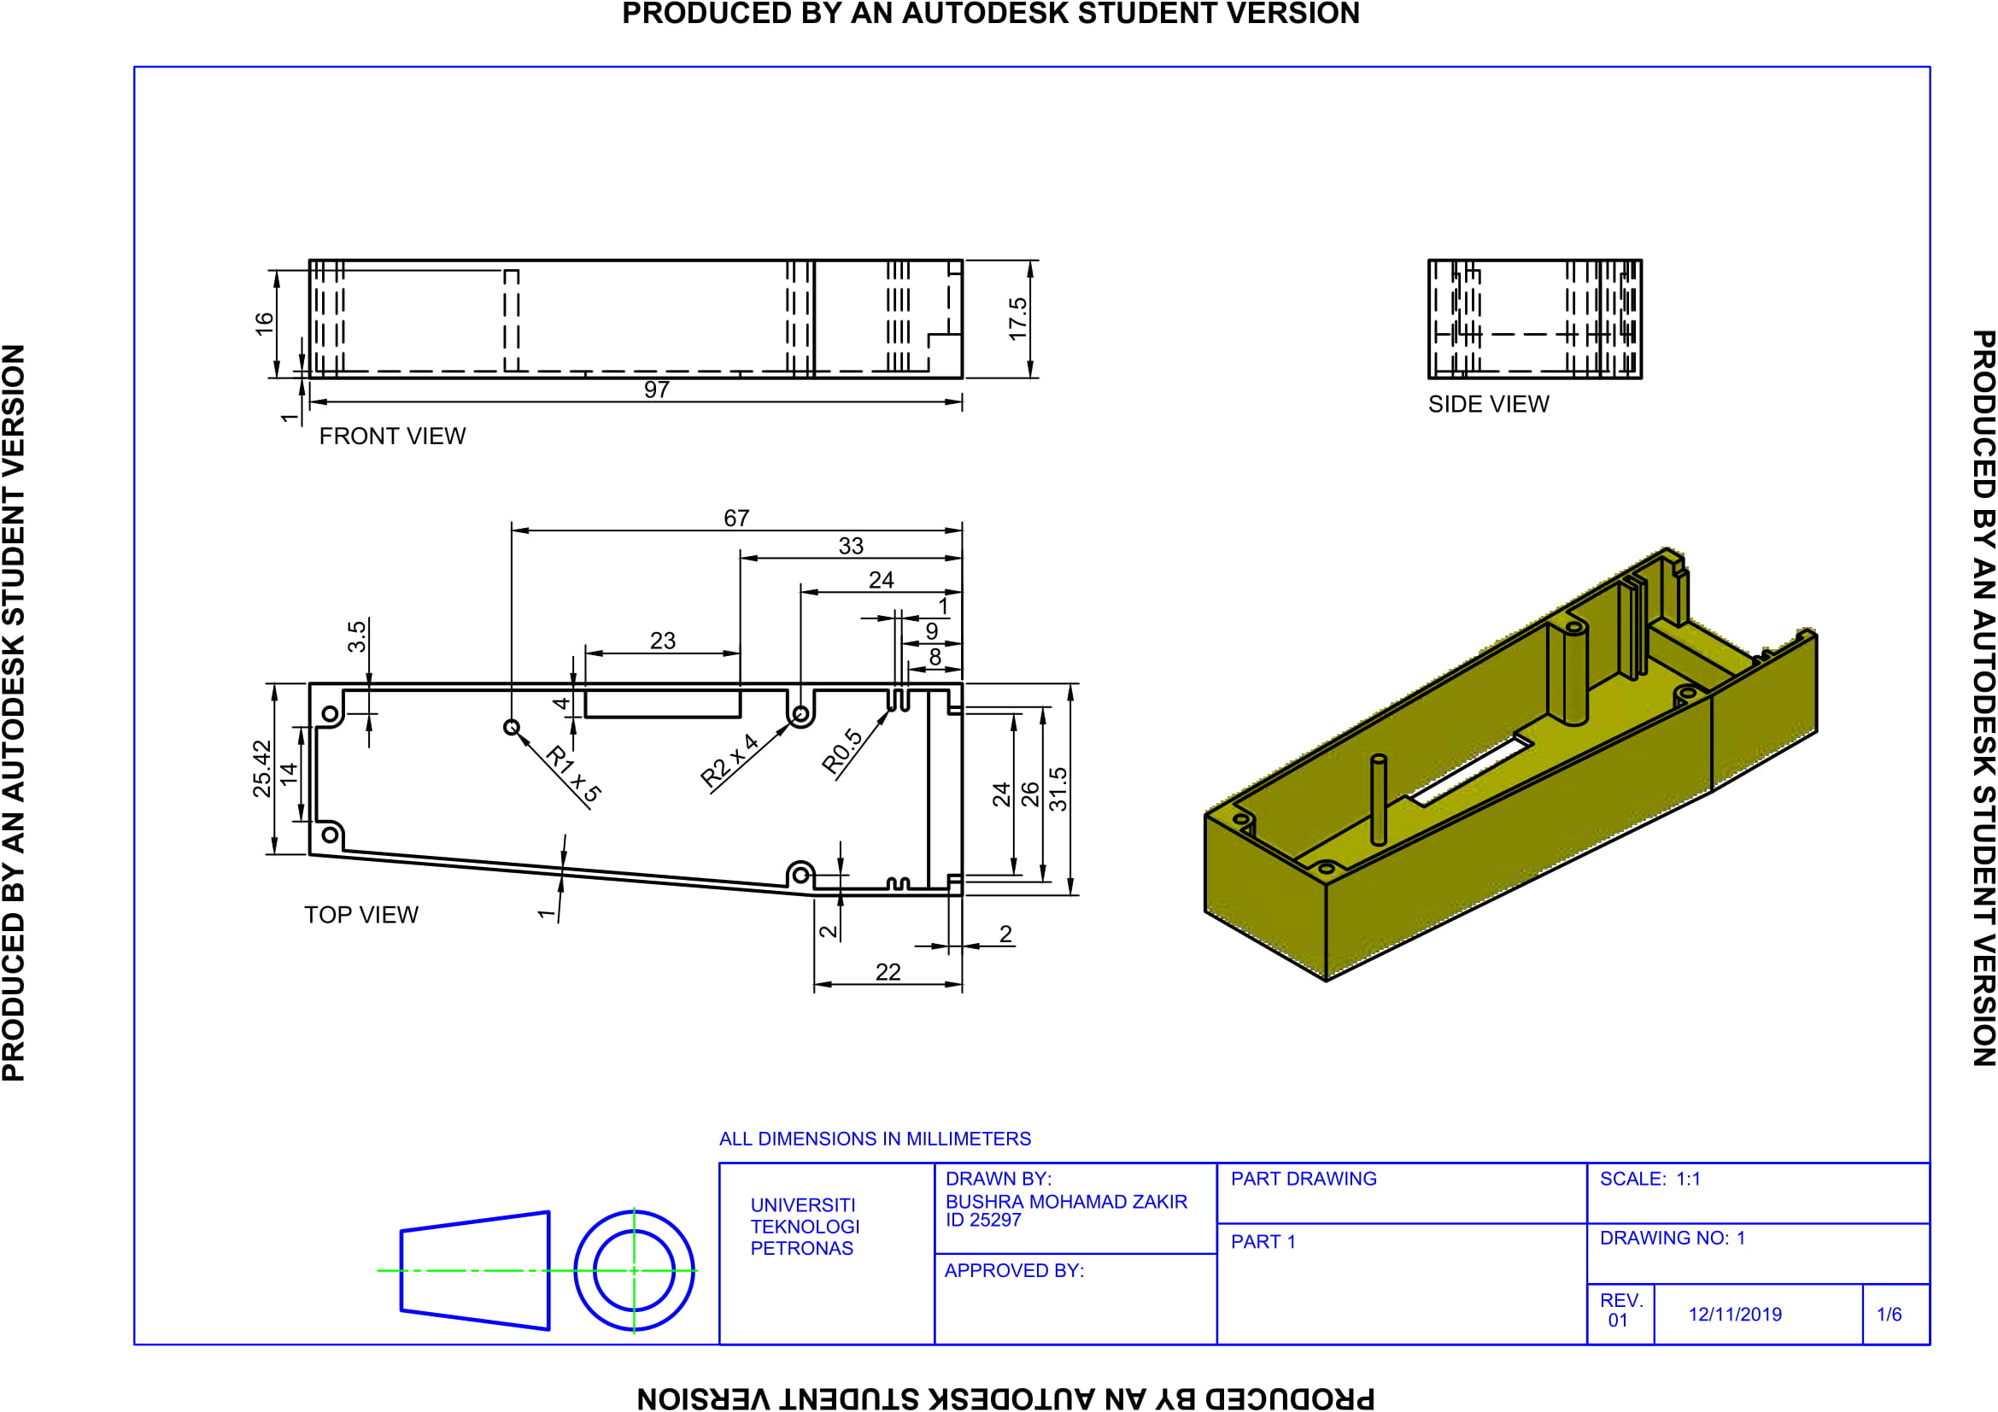

*Figure 3.1.1 engineering drawing of 3D casing at the bottom back of the casing (part 1)*

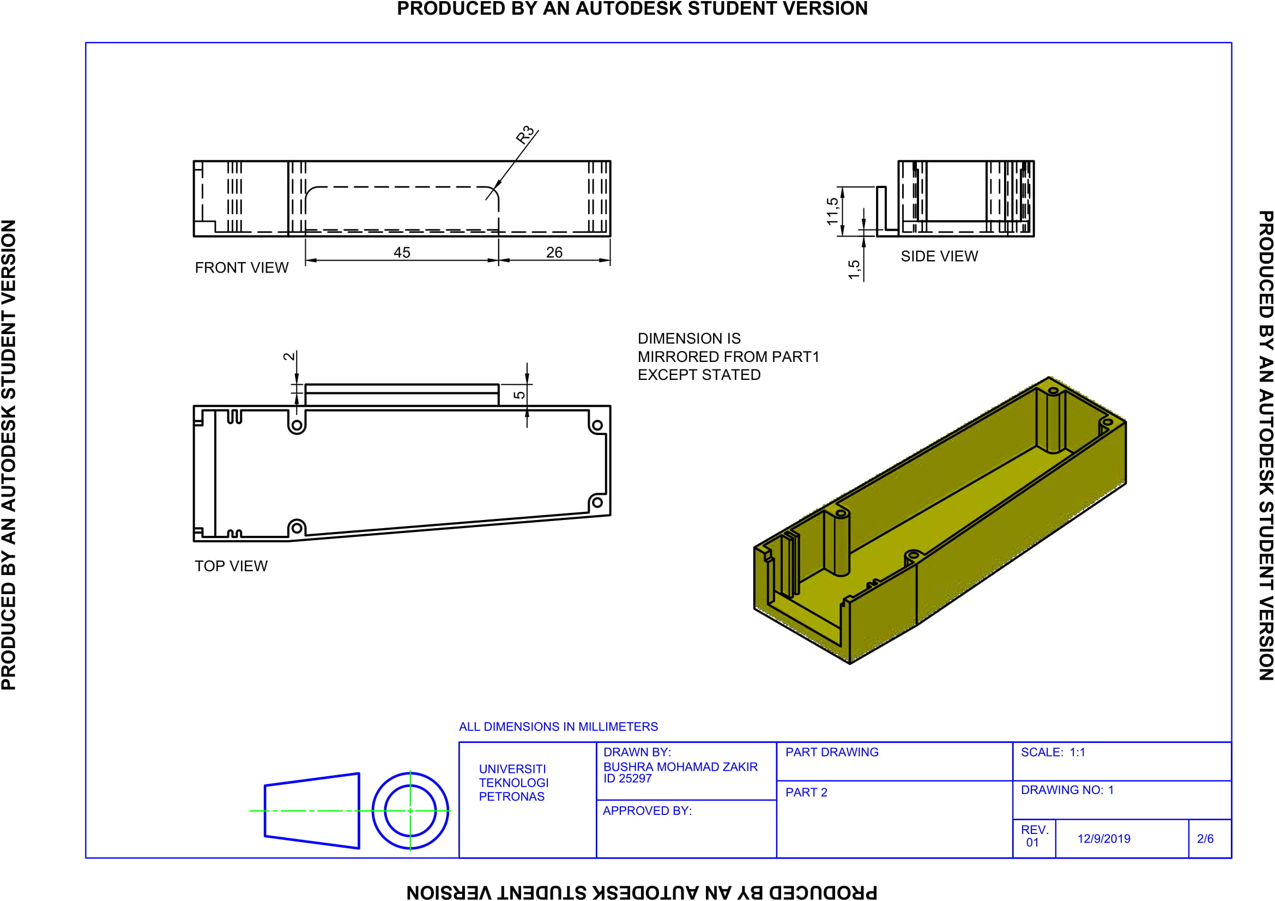

*Figure 3.1.2 engineering drawing of 3D casing at the top back of the casing (part 2)*

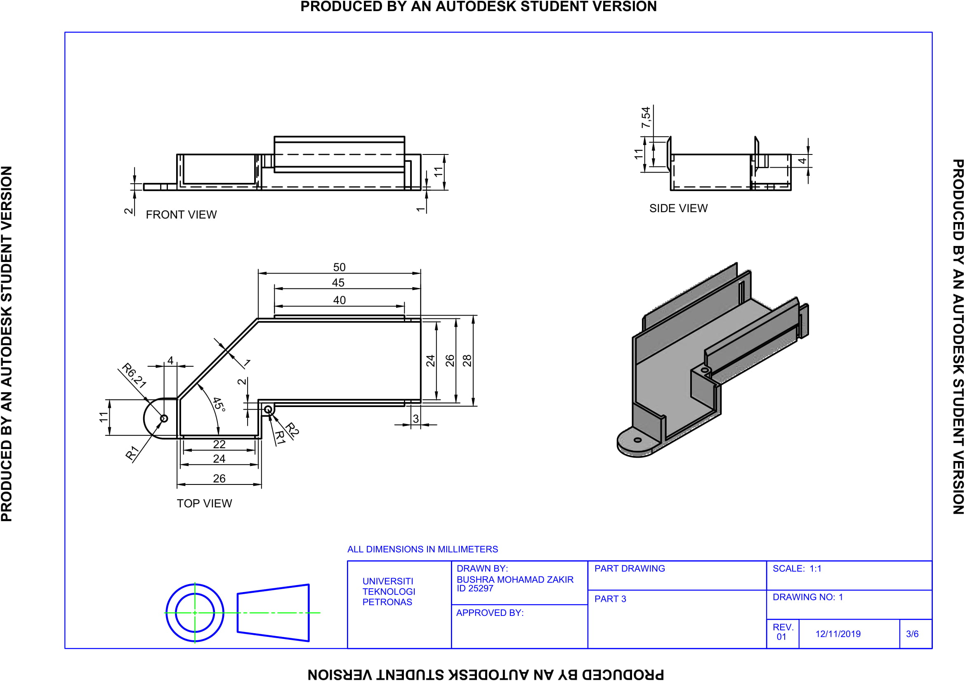

*Figure 3.1.3 engineering drawing of 3D casing at the bottom front of the casing (part 3)*

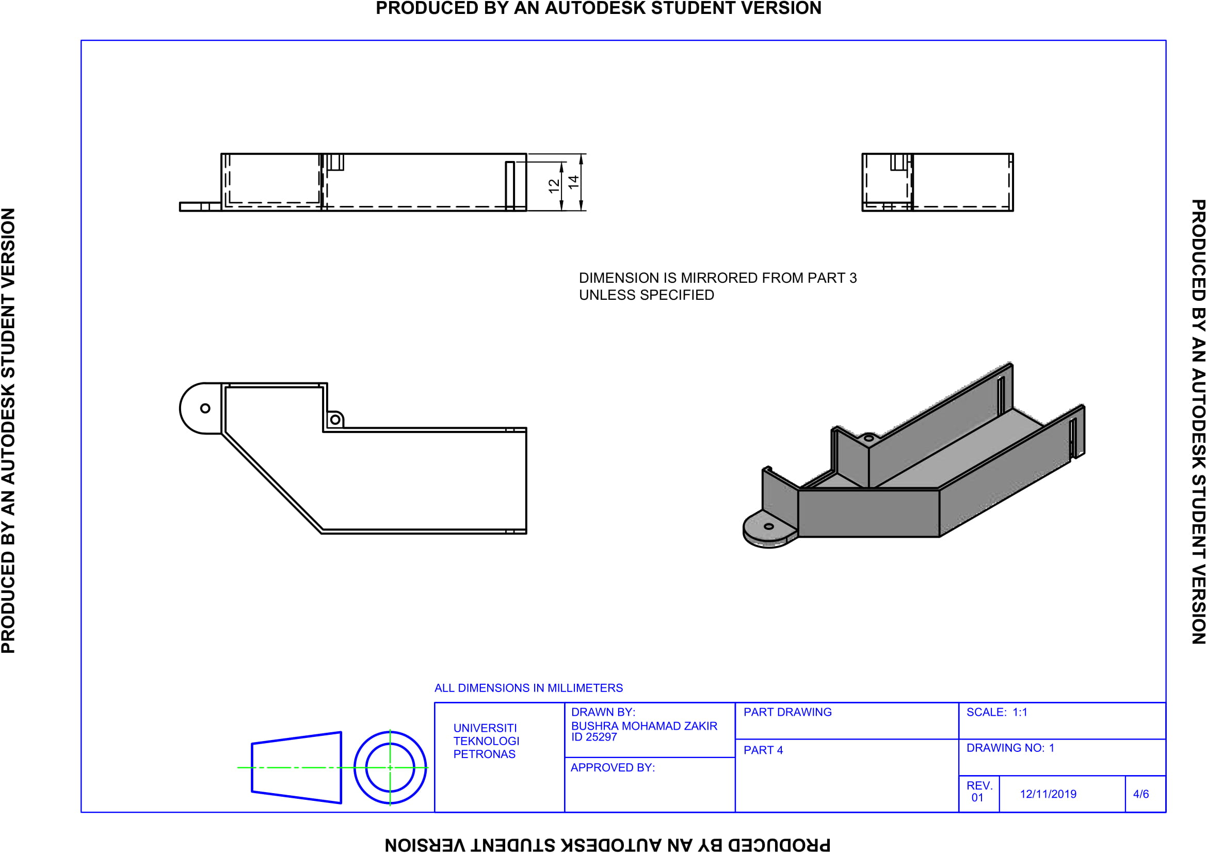

*Figure 3.1.4 engineering drawing of 3D casing at the top front of the casing (part 4)*

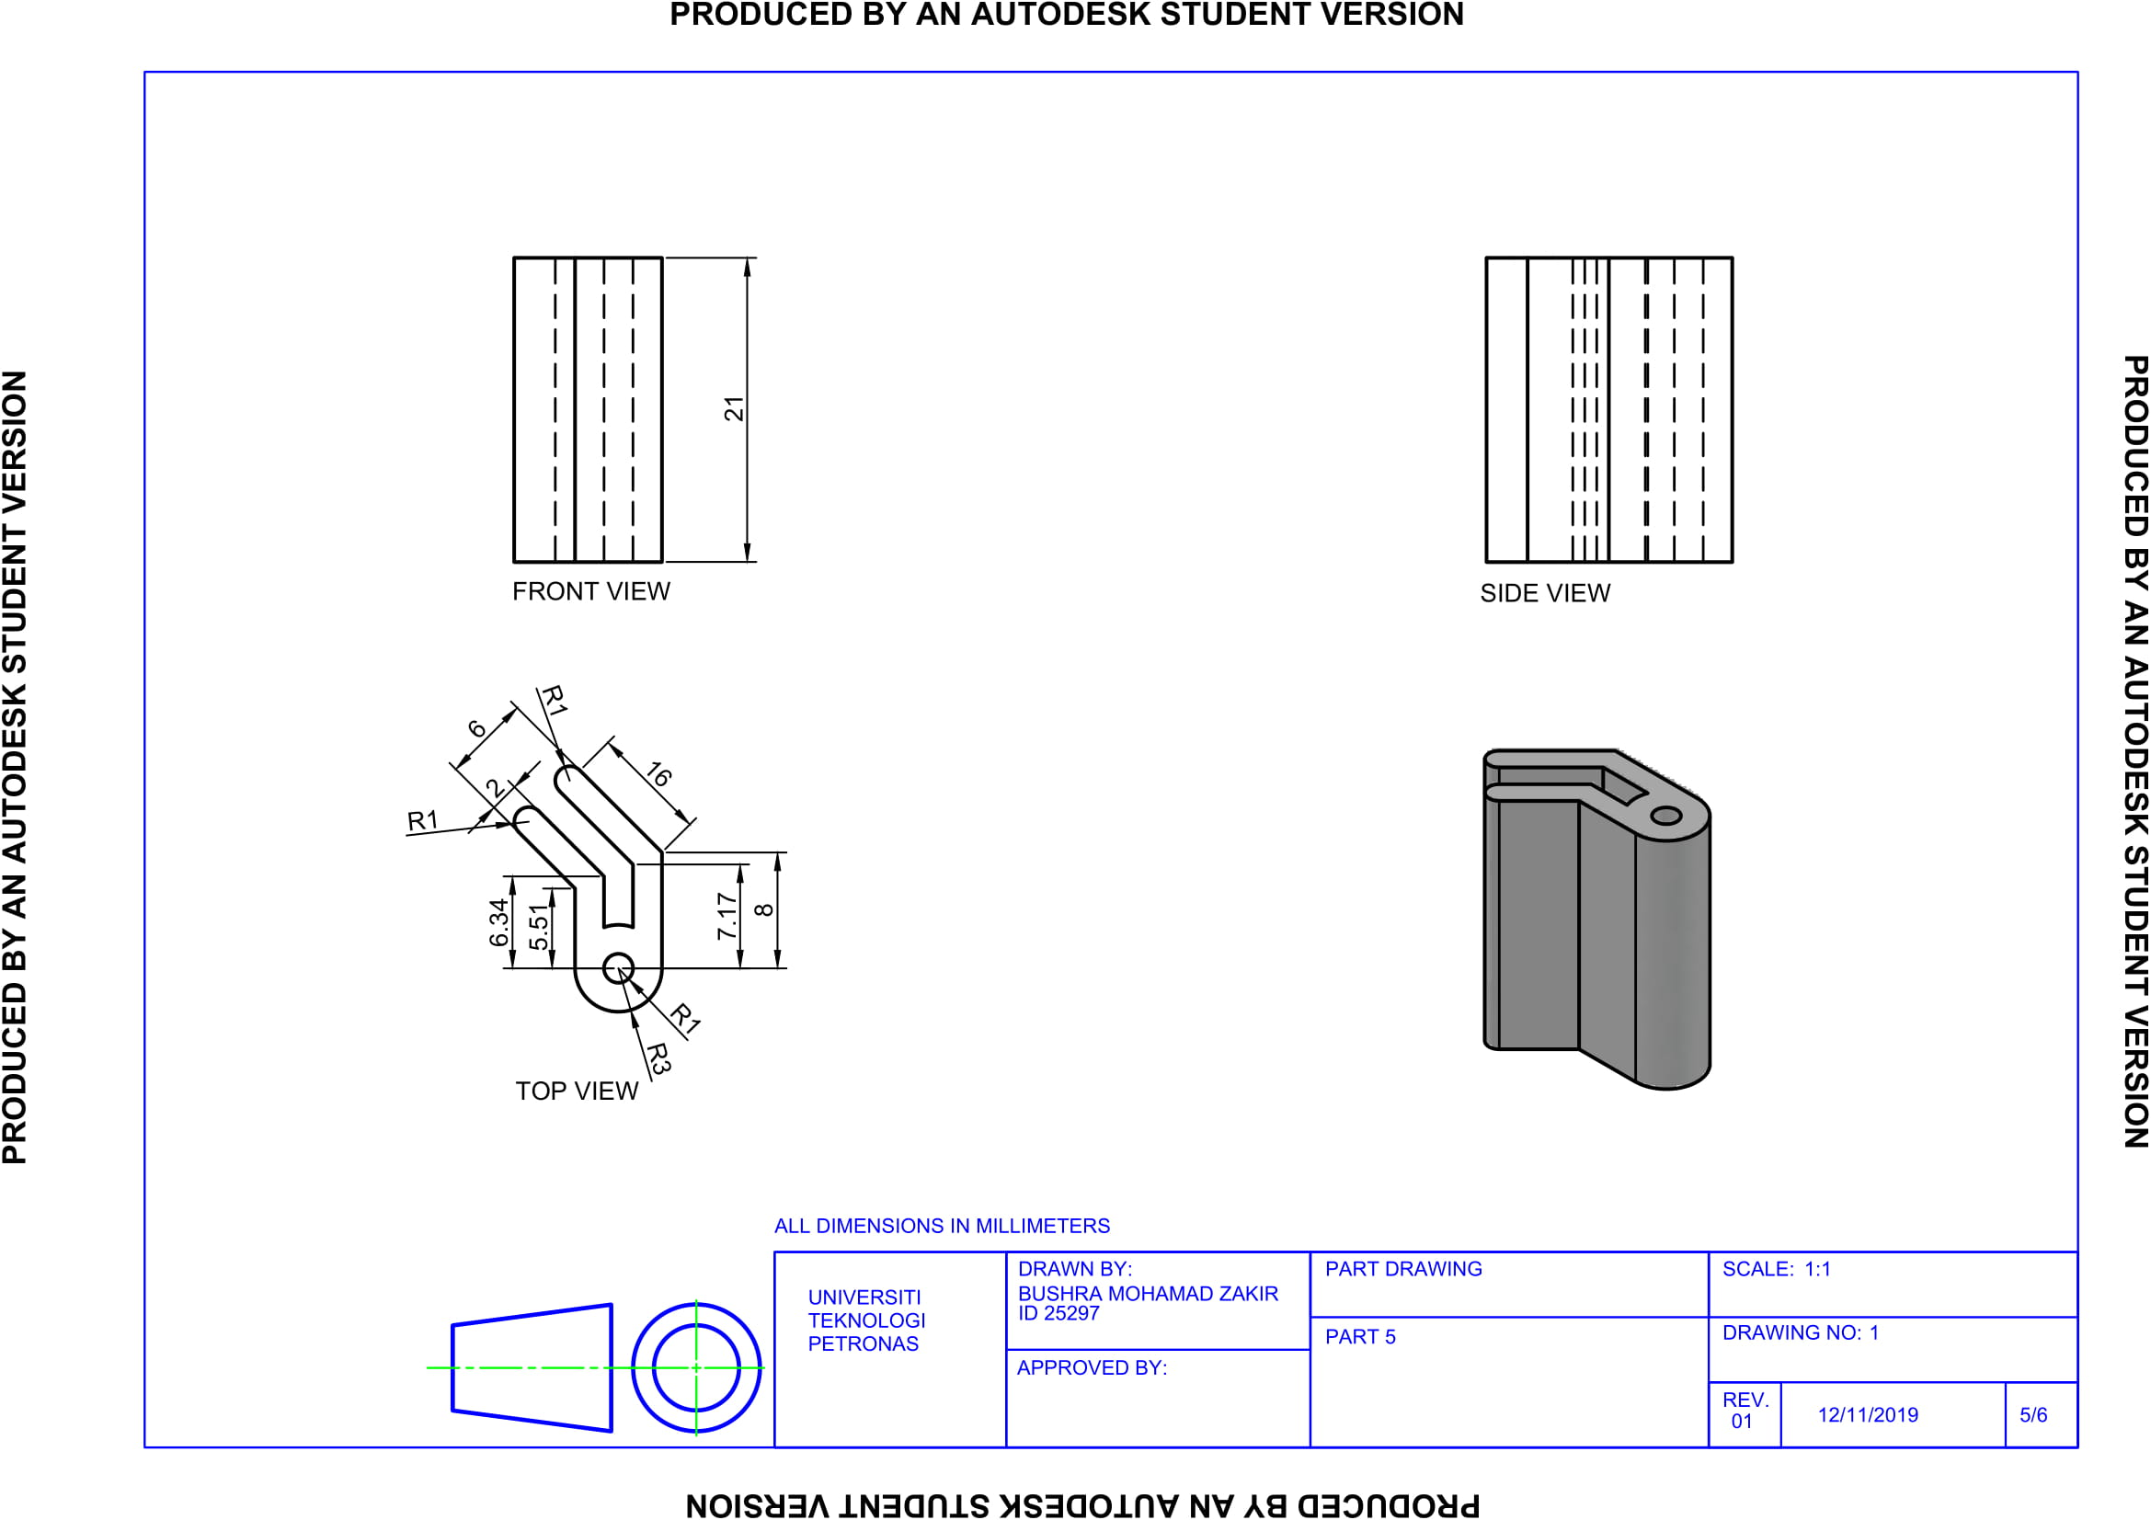

*Figure 3.1.2 engineering drawing of 3D casing that connect the casing with the reflector(lens) (part 5)*

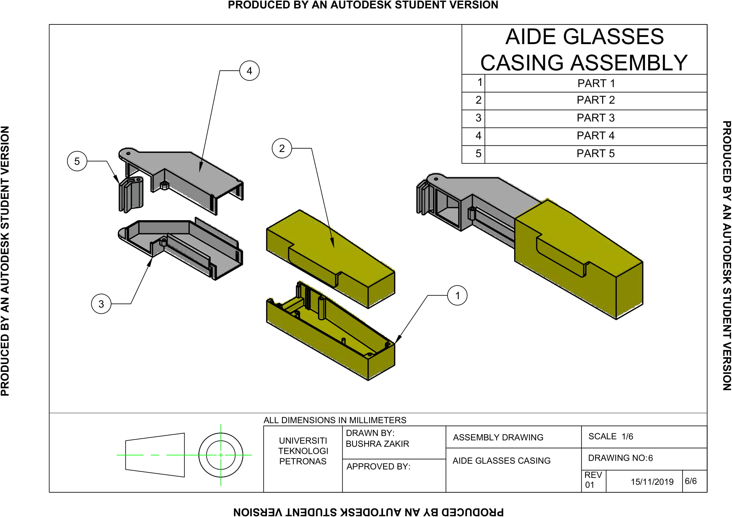

*Figure 3.1.2 Overall engineering drawing of 3D printed casing*

**3.2. PROJECT OUTPUT**

For this project, we have produced a prototype of Aide Glasses as shown in Figure 3.2.1 and developed a mobile application named Aide Glass. Figure 3.2.2 shows the screenshot of the mobile application. The application allows different choice of language either English or Malay. The application works by prompting the user to choose the preferred language either English or Malay and the conversation can be started. Once the conversation started, the transcription will be displayed on the OLED display and later on reflected to the mirror and finally to the Perspex screen. Furthermore, the result and history of transcription can be viewed in the mobile application.

The application were made using React Native, a mobile development framework developed by Facebook. The transcriptions are stored in database using Firebase service by Google. As the program that records audio, transcribe, and display the transcribed text run separately inside the microcontroller of Aide Glass, Aide Glass can run independently without the app. However, the app provides the capability of changing the language and seeing the transcription history.

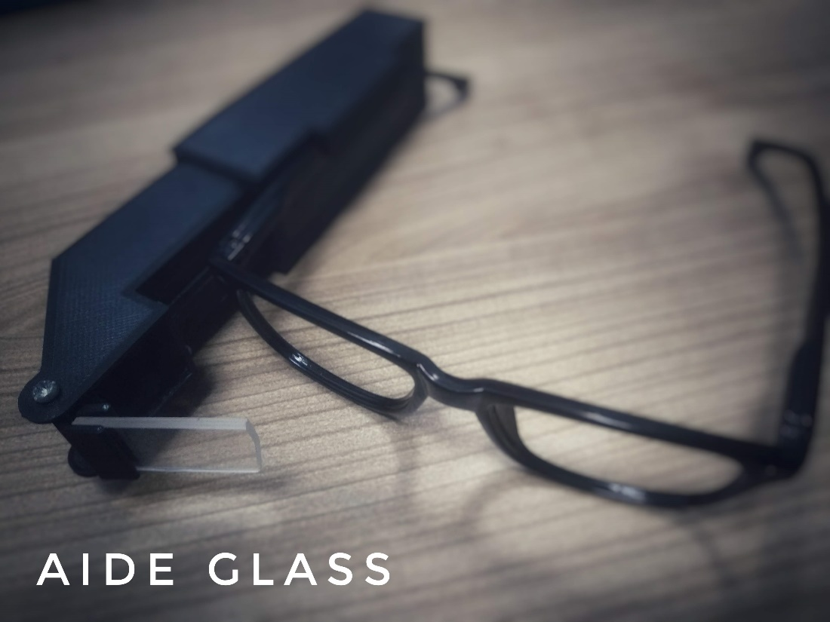

*Figure 3.2.1 Aide Glass Prototype*

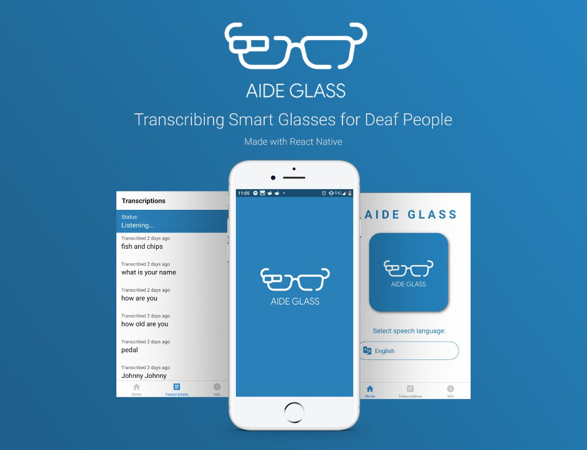

*Figure 3.2.2 Aide Glass Mobile App*

**3.3. DISCUSSION ON RESULTS**

The performance and specification of the resulting prototype has been measured and discussed in this section. The discussion can be seen in Table 3.3.1.

*Table 3.3.1 table of criteria and discussion of results obtained.*

|  |  |
| --- | --- |
| **CRITERIA** | **DISCUSSION** |
| Weight of casing + components | * The overall weight of the prototype is 70g. The weight includes 3D casing, PI Zero WH, OLED display, microphone, reflective mirror and magnifying Fresnel lens. 70g is quite heavy for an attachment on a pair of spectacles. Hearing aids like Widex Evoke only weight around 5g but would cost 1,864 USD (Hearingtracker, 2019) and a normal glass weight around 25g(Walsh, 2010) without attachment. However, the weight can be reduced by resizing the casing have best fit with the components. |
| Dimension | * As shown in section 3.1, the dimension of Aide Glasses prototype is portable but the size needs to be adjusted into a smaller dimension so that it would give more comfort to the user. |
| Sound detectable distance | * Based on the testing of prototype by giving voice input in 0.1m – 2.5m distance with 0.1m difference for each test. We conclude that the human sound detectable distance is around 1.5m in quiet environment. A distance longer than that give unrecognized output 80% of the time. |
| Speech to text transcribing speed | * In overall, it took less than 10 second to process the spoken word into a script displayed on the screen. |
| Mirror angle | * After we tested all angles for the reflector from 0-50 (max angle) degree with 5 degree increment, we found that angle at 45 degree gives the best reflection of text from the OLED display to the Perspex screen. With this angle, all text was successfully reflected to the screen. |
| Mobile application | * A mobile application named AIDE GLASS were also developed to run together with this prototype. The great thing about Aide glasses prototype is that it can run with or without the mobile application. * The mobile application has the options of switching between English and Malay language and it also record all the history of the transcribed text so that the user can always refer what is the conversation all about. |

**3.4. COST ANALYSIS**

**CAPITAL COST**

Capital cost can be defined as the cost that is needed to build a prototype of the product. In this case, the materials with their pricing will be shown in **Table 3.4.1** below. All the cutting tools and attaching tools are not included in the capital cost. It will only consider the cost of those physical materials which are included in the final product.



*Table 3.4.1 cost for each material used*

|  |  |  |  |  |
| --- | --- | --- | --- | --- |
| **No** | **Item** | **Quantity** | **Cost per Item (RM)** | **Total Cost (RM)** |
| 1 | Raspberry Pi Zero WH | 1 | 64.40 | 64.40 |
| 2 | OLED Display | 1 | 25.00 | 25.00 |
| 3 | Mini Powerbank 2600mAh | 1 | 9.95 | 9.95 |
| 4 | Plastic Mirror | 2 | 0.70 | 1.40 |
| 5 | Fresnel Lens | 2 | 0.25 | 0.50 |
| 6 | USB Microphone | 1 | 5.90 | 5.90 |
| 7 | MicroUSB to OTG Adapter | 1 | 8.05 | 8.05 |
| 8 | 3D Printed Casing | 1 | 1.00 per gram | 25.00 |
| 9 | Perspex | 1 | - | - |
| 10 | Reading Glasses | 1 | 2.30 | 2.30 |
| 11 | SD Card 16gb | 1 | 36.00 | 36.00 |
| **TOTAL** | | | | 178.50 |

**OPERATIONAL COST**

There is no major operational cost incurred for this product. The mini powerbank as the power source needed to be recharged once it drains out. Since the prototype has low power consumption, the powerbank will last long enough. Pi Zero WH will consume around 0.08W and 0.24W with the power supply at 12W from the powerbank at constant 2.1A. Based on the recommendation from the Raspberry Pi company, it is recommended to use Power Supply Unit (PSU) with 1.2A current capacity. However, the maximum current that is needed to run the Pi Zero WH is 500mA. Hence, it will last for at least 24 hours before the 2,600mAh powerbank run out.

**ALTERNATIVES IN MATERIAL**

ESP32 LyraT has been considered as the alternative main board to run the system for Aide Glass. The comparison between Raspberry Pi Zero WH and ESP32 LyraT in term of economical aspect is shown in **Table 3.4.2**. Based on the comparison table, power requirement of Pi Zero WH need 1.2A which is slightly higher than ESP32 LyraT, 500mA. However, ESP32 LyraT is not space efficient because it consumes larger while the Pi Zero WH. Therefore, a larger casing is needed to place ESP32 LyraT in the prototype which will increase the cost for casing production. Raspberry Pi Zero WH is more preferable in term of the economical aspect after few considerations are made.

*Table 3.4.2 shows the comparison based on the economical aspect*

|  |  |  |
| --- | --- | --- |
| **Raspberry Pi Zero WH** | **Parameter** | **ESP32 LyraT** |
| RM 75.00 with shipping included (Shopee, 2019) | **Price** | RM 108 (AliExpress, 2019) |
| 1.2A | **Power Requirement** | 500mA |
| 65mm x 30mm | **Space Consumption** | 95.5mm x 80.6mm |

As for fabrication material, the comparison between cardboard, and 3d printed plastic has been made earlier in *Table 2.3.4*



**3.5. CONCLUSION**

In conclusion, ETP Group 7 have successfully produced a working prototype of a smart glasses named Aide Glasses. Aide glasses is a smart glasses which works by capturing sound waves and processing them into text using Google speech to text recognition function. Voice recognition system in Aide Glass is capable of helping hearing-impaired people by displaying each of words that has been uttered by the person who is talking to them. By using the Aide Glasses application, the person who is using the product can change the language of transcription and also view the recorded transcribed words. Aide Glasses is an inexpensive alternative to hearing aids as the overall cost of production is only RM 178.50, sixteen times cheaper than other hearing aids.

There are several human errors that could be solved in order to obtain a high accuracy result. Firstly, the pronunciation of each words should be clear and concise as google speech recognition require a correct pronunciation to produce an accurate result. Besides, it is best to use this device in a quiet environment so that there are no unnecessary noises around that could affect the result of transcription. Furthermore, the speed of spoken words should be not too fast as it could affect the accuracy of result. Despite of using 3D printed casing, the dimension is too large, and its weight is quite heavy to be held by a pair of spectacles. Hence, most of these will be improved and explained in the recommendation section.

**3.6. RECOMMENDATIONS**

After analyzing the results of the produced prototype, we have discussed the improvements and recommendation that can be made to the prototype in the future. The discussion of the improvements were shown in Table 3.5.1.

*Table 3.5.1. recommendations to improve the performance of the prototype*

|  |  |
| --- | --- |
| **CRITERIA** | **IMPROVEMENTS** |
| Dimension and weight | * Based on the output of the prototype, it was found that although the weight is very light, it still gives some uncomfortable feeling to the user as the weight is saturated only on one side of the user glasses. Thus, it is not that stable. * To improve this, several components need to be changed into a smaller component. Besides that, the weight on both side of the glasses should be balanced by adding some weight at the other side of the glasses. |
| Power source | * In average, Raspberry PI Zero WH consumes 3.3v power. The high-power consumption was due to Wi-Fi connection of Raspberry PI Zero WH. For a 10000mAH power bank, Aide Glasses can run up to 10 hours of continuous usage. |
| Quality of microphone | * The microphone purchased for this project was a relatively cheap microphone, thus it does not have the ability to filter out surrounding noise resulting in medium accuracy of text transcribed to the screen. * To resolve this, a higher quality microphone which has the ability to filter surrounding noises should be used so that only human voices will be detected so that the transcription is more accurate. |
| Quality of magnifying Fresnel lens | * The magnifying Fresnel lens that were used to magnify the text produced by OLED display were not able to produce a sharp image upon magnification. * To resolve this, a magnifying glass should be used instead of a magnifying Fresnel lens. |
| Quality of screen (Perspex) | * The Perspex used as the screen are transparent, thus the image produced from the reflection and magnification process is not really clear in a bright environment. * To solve this, a tinted Perspex should be used as the screen so that the image produced in a broad daylight is clear. |

**4. PROJECT MANAGEMENT**

We have identified the tasks need to be done and distributed the tasks evenly to each of our member. We also have given each member their role and responsibilities for the duration of the project based on consensus.

**4.1 GANTT CHART**

The Gantt chart of the project which shows the technical tasks, person in charge, and expected timeline can be seen in Table 4.1.

*Table 4.1 Gantt Chart*

|  |  |  |  |  |  |  |  |  |  |  |  |  |  |  |
| --- | --- | --- | --- | --- | --- | --- | --- | --- | --- | --- | --- | --- | --- | --- |
| **SPECIFIC TASKS** | **PIC** | **WEEK** | | | | | | | | | | | | |
| **1** | **2** | **3** | **4** | **5** | **6** | **7** | **8** | **9** | **10** | **11** | **12** |
| Survey form preparation | Megat Khairil & Muhammad Fathy Rashad |  |  |  |  |  |  |  |  |  |  |  |  |
| Prepare engineering drawing & 3D drawing of prototype | Syed Amir |  |  |  |  |  |  |  |  |  |  |  |  |
| Components buying and collection | Syed Amir & Muhammad Fathy Rashad |  |  |  |  |  |  |  |  |  |  |  |  |
| Data interpretation based on survey result | Ahmad Kamal |  |  |  |  |  |  |  |  |  |  |  |  |
| Finishing extended proposal | All member |  |  |  |  |  |  |  |  |  |  |  |  |
| Circuit design and construction | Muhammad Fathy Rashad & Megat Khairil |  |  |  |  |  |  |  |  |  |  |  |  |
| Testing reflective display to the lens. | Syed Amir |  |  |  |  |  |  |  |  |  |  |  |  |
| Software system development & testing | Muhammad Fathy |  |  |  |  |  |  |  |  |  |  |  |  |
| Testing of working prototype | Bushra & Fiorentina |  |  |  |  |  |  |  |  |  |  |  |  |
| Poster design | Ahmad Kamal & Fiorentina |  |  |  |  |  |  |  |  |  |  |  |  |
| poster presentation preparation | All member |  |  |  |  |  |  |  |  |  |  |  |  |
| Poster presentation and product demonstration | All member |  |  |  |  |  |  |  |  |  |  |  |  |
| Finishing final report | All member |  |  |  |  |  |  |  |  |  |  |  |  |
| Final report submission | All member |  |  |  |  |  |  |  |  |  |  |  |  |

**4.2. TASK ALLOCATIONS**

We have allocated each member both general tasks such as secretary and treasurer tasks and also specific tasks based on our project requirement. The task distributions of the general tasks can be seen in Table 4.2.1 and the specific tasks distribution is shown in Table 4.2.2.

*Table 4.2.1 General task division*

|  |  |
| --- | --- |
| **NAME & POSITION** | **GENERAL TASKS** |
| Muhammad Fathy Rashad  (Project manager) | * In charge of the software and programming part. * Manage the project, ensure all members completed the task on time. * Ensure the project is done according to plan. * Ensure the proposal, report and other documents are done and submitted on time. |
| Bushra Binti Mohamad Zakir  (Secretary) | * Prepare engineering drawing of the prototype. * Prepare 3D drawing of the prototype for 3D printing purposes. * Arrange meeting time with supervisor. * In charge of mechanical part of the prototype. |
| Fiorentina Richelle Asun  (Treasurer) | * Manage group’s fund. * Ensure purchases made is within the budget provided by UTP. * Safekeeping of the receipt for claiming purposes. |
| Ahmad Kamal Bin Kamaluddin | * Analyze problem faced during prototype fabrication and point it out in the discussion. * Compiling extended proposal and final report. |
| Megat Khairil Azlan bin Adlin Azam | * In charge of electronic part for the project. * To come out with different materials related to electronic. |
| Syed Amir Hilmy Bin Syed Halim | * Prepare the engineering drawing of the prototype. * Prepare 3D drawing of the prototype casing for 3D printing purposes. * Ensure all the materials needed are available. |

*Table 4.2.2 specific tasks delegation among ETP group 7 members.*

|  |  |  |
| --- | --- | --- |
| **SPECIFIC TASKS** | **PIC** | **DESCRIPTIONS** |
| Survey form preparation | Megat Khairil & Muhammad Fathy Rashad | * Preparing survey form in google forms and share the survey link to all group members to be blasted in all Whatsapp groups. |
| Prepare engineering drawing & 3D drawing of prototype | Bushra & Syed Amir | * Prepare engineering drawing for the prototype using Computer Aided Design (CAD) software and prepare 3D drawing of the prototype casing for 3D printing purposes. |
| Components buying and collection | Syed Amir & Ahmad Kamal | * Searching and collecting of components from ETP store. * Buying additional required components that is not available in ETP store. |
| Data interpretation based on survey result | Ahmad Kamal | * Interpreting the results of survey conducted to be included in the extended proposal. |
| Circuit design and construction | Muhammad Fathy Rashad & Megat Khairil | * Designing the circuit of the prototype. * Design the location of Raspberry Pi Zero WH, OLED display, mini powerbank, USB microphone, and micro USB to OTG adapter * Construct the circuit based on the design |
| Testing reflective display to the lens. | Syed Amir | * Fitting of reflective display to the glasses lens to ensure it is compatible with normal glasses. |
| Software system development and testing | Muhammad Fathy Rashad | * Development and testing of Google Cloud Speech-to-Text service to do speech recognition on the audio input of the prototype. * Development and testing of program run by the microcontroller. * Development of mobile app. |
| Testing of working prototype | Bushra & Fiorentina | * Ensure the reflective display on the lens will display the subtitle of the text spoken by people. * Ensure the prototype is useable and comfortable for people with hearing impairment. |

**REFERENCES**

10 PCS Card Credit 3 Magnifier X Magnification Magnifying Fresnel LENS UEB2-tyou. Retrieved from <https://shopee.com.my/product/129771583/2633789313>

Centers for Disease Control and Prevention. (2018). Loud Noise can Cause Hearing Loss. Retrieved from https://www.cdc.gov/nceh/hearing_loss/how_do_i_prevent_hearing_loss .html.

Cloud Speech-to-Text. Retrieved from https://cloud.google.com/speech-to-text/.

CMUSphinx Documentation. Retrieved from <https://cmusphinx.github.io/wiki/>.

ESP32-LyraT V4.3 Getting Started Guide. Retrieved from <https://docs.espressif.com/projects/esp-adf/en/latest/get-started/get-started-esp32-lyrat.html>

Espressif Official ESP32-LyraT Open-Source Voice/Audio/WiFi/Bluetooth Development Board w/ Touch + Physical Buttons Support PTZ. Retrieved from <https://www.aliexpress.com/item/32971926978.html>

Felman, A. (2018). What’s to Know about Deafness and Hearing Loss? *Medical News Today.* Retrieved from <https://www.medicalnewstoday.com/articles/249285.php>.

Gazetić, E. (2017). Comparison Between Cloud-based and Offline Speech Recognition Systems.

Hear.com. (n.d.). Hearing Aid Prices. Retrieved from https://www.hear.com/my/hearing aids/prices.

Huang, X. (2018, June 13). Microsoft researchers achieve new conversational speech recognition milestone. Retrieved from https://www.microsoft.com/en-us/research/blog/microsoft researchers-achieve-new-conversational-speech-recognition-milestone/.

Këpuska, V., & Bohouta, G. (2017). Comparing speech recognition systems (Microsoft API, Google API and CMU Sphinx). Int. J. Eng. Res. Appl, 7(03), 20-24.

Mayo Clinic. (n.d.). Hearing Loss. Retrieved from https://www.mayoclinic.org/diseases conditions/hearing-loss/symptoms-causes/syc-20373072.

**REFERENCES**

Mini USB 2.0 Microphone Portable Studio Speech MIC Audio Adapter Driver Free For MSN PC Notebook. Retrieved from https://www.lazada.com.my/products/mini-usb-20-microphone-portable-studio-speech-mic-audio-adapter-driver-free-for-msn-pc-notebook-i485600907-s833796394.html

Mohr, P. E., Feldman, J. J., Dunbar, J. L., Mcconkey-Robbins, A., Niparko, J. K., Rittenhouse, R. K., & Skinner, M. W. (2000). The Societal Costs of Severe to Profound Hearing Loss in The United States. International Journal of Technology Assessment in Health Care, 16(04), 1120–1135.

Moore, M. S. (2004). For Hearing People Only. Deaf Life Press

Original Remax RA-OTG USB 2.0 To MicroUSB Connection Kit OTG Adapter. Retrieved from <https://shopee.com.my/Original-Remax-RA-OTG-USB-2.0-To-MicroUSB-Connection-Kit-OTG-Adapter-i.60955352.2304767765>

Raspberry Pi Zero W. Retrieved from <https://www.raspberrypi.org/products/raspberry-pi-zero-w/>

Raspberry Pi Zero WH (with Header). Retrieved from <https://shopee.com.my/Raspberry-Pi-Zero-WH-(with-Header)-i.23949362.1136441442>

Stinson, M., & Liu, Y. (1999). Participation of deaf and hard-of hearing students in classes with hearing students. Journal of Deaf Studies and Deaf Education, 4, 191–202.

The Star Online. (2015). Surgeon: Cochlear Implants can Give the Hearing Impaired a Sense of Involvement with Daily Life. Retrieved from https://www.thestar.com.my/metro/community/2015/05/02/bringing-hope-to-the-deaf surgeon-cochlear-implants-can-give-the-hearing-impaired-a-sense-of-involve.

World Health Organization. (2019). Deafness and Hearing Loss. Retrieved from <https://www.who.int/news-room/fact-sheets/detail/deafness-and-hearing-loss>.

ZPO High Quality Powerbank 2600mAh Mini Keychain Perfume Lipstick Portable Power Bank. Retrieved from <https://www.lazada.com.my/products/zpo-high-quality-powerbank-2600mah-mini-keychain-perfume-lipstick-portable-power-bank-i548228279-s1088284023.html>

**REFERENCES**

Mueller, H. Gustav, et al. “The Effects of Digital Noise Reduction on the Acceptance of Background Noise.” Trends in Amplification, vol. 10, no. 2, 2006, pp. 83–93., doi:10.1177/1084713806289553.

Walsh, G., (2010). The weight of spectacle frames and the area of their nose pads. *Ophthalmic Physiol Opt. 30*(4), 402-4. doi: 10.1111/j.1475-1313.2010.00755.x.

Widex EVOKE Hearing Aids (2019). Retrieved from <https://www.hearingtracker.com/hearing-aids/widex-evoke>.

Hill, Sue, and Roger Wicks. HEARING LOSS AND EMPLOYMENT. May 2017, https://www.england.nhs.uk/wp-content/uploads/2017/09/hearing-loss-what-works-guide-employment.pdf.